**Current Plan**

Now we have decided to continue our project Using image processing, we can use **python open cv library** to do the image processing part.

Steps

1. Find a suitable **algorithm** to identify how to structure the code.
2. Use the internet sources to find out how the image processing is done for shrinkage. (Research paper) and find a suitable algorithm.
3. Mean while convert the algorithm into python code.
4. Find how the output is coming out of the program.
5. According to the output, Build a **R program** to analyze the output and convert the data into readable form for Brandix.
6. Meanwhile build the **Apparatus**.

**Add all the necessary files and the files that are currently working to the Google drive shared and the GitHub Repository.**

* Capturing the image before marking the dots and then capturing the image again after marking the dots and then overlapping the image to find the added dots.
* Regions are identified where the dots will be.

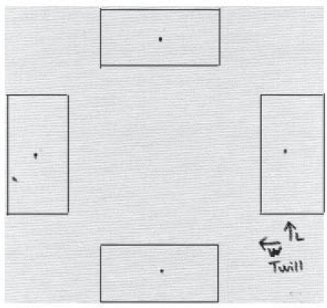

* Scanning the image according to the size of the dot.
* Scanning the dot according the color.